839 Fourth Avenue Lake Odessa, MI 48849 Phone: (616) 374-3264 Fax: (616) 374-0040
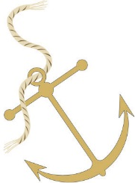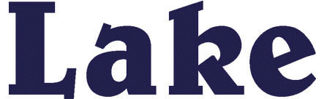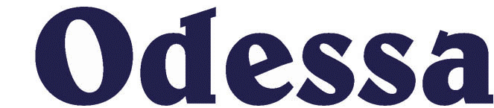

AUTHORIZATION AGREEMENT FOR DIRECT PAYMENTS (ACH DEBITS)

Company Name: LAKEWOOD WASTEWATER AUTHORITY & VILLAGE OF LAKE ODESSA

I (we) hereby authorize LAKEWOOD WASTEWATER AUTHORITY & THE VILLAGE OF LAKE ODESSA, hereinafter called COMPANY, to initiate debit entries to my (our) Checking Account/ Savings Account (select one) indicated below at the depository financial institution named below, hereinafter called DEPOSITORY, and to debit the same to such account. I (we) acknowledge that the origination of ACH transactions to my (our) account must comply with the provisions of U.S. law.

Name of Financial
Institution____________________________ Branch______________________________

City________________________________ State________________ Zip____________

Routing Account
Number_____________________________ Number_____________________________

This authorization is to remain in full force and effect until COMPANY has received written notification from me (or either of us) of its termination in such time and in such manner as to afford COMPANY and DEPOSITORY a reasonable opportunity to act on it.

Name(s)_____________________________ Water/Sewer Account #_______________________________

Date________________________________ Signature __________________________________________

Phone______________________________

NOTE: ALL WRITTEN DEBIT AUTHORIZATIONS MUST SPECIFY THAT THE RECEIVER MAY REVOKE THE AUTHORIZATION ONLY BY NOTIFYING THE ORIGINATOR IN THE MANNER SPECIFIED IN THE AUTHORIZATION.

